**AR/VR ASSIGNMENT**

**BY: HUZAIFA PATEL**

**ID: 22000260**

**Task 1:** Set up Unity project and configure the VR environment

**Steps:-**

Open unity

Install XR interaction tool kit

Import starter assets

Import XR device simulator

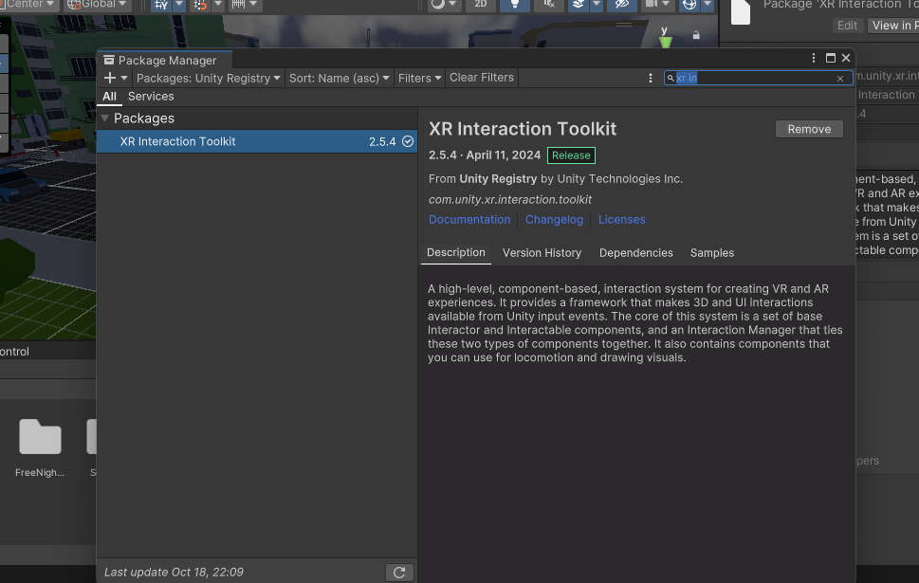

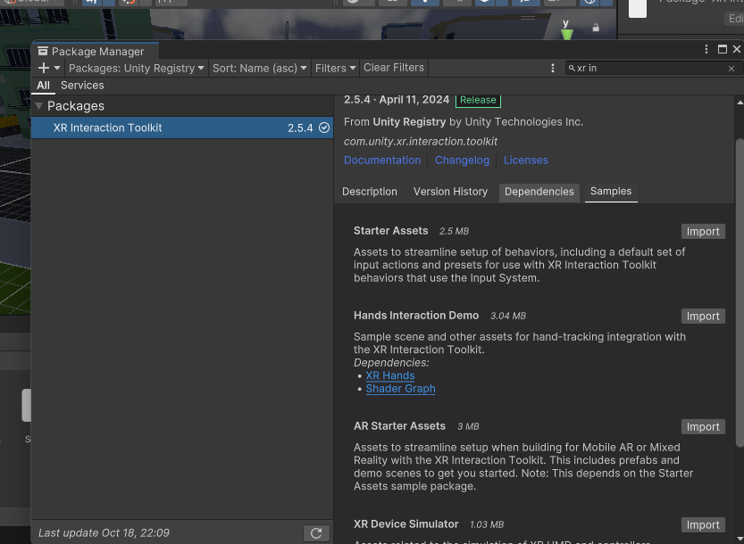

**Task 2:** Create a ground plain environment for eg: city environment

Steps:-

Create an environment where a player can move around

Import environment from asset store

Download it in unity

Import it

Implement it in the scene

Screenshots:-

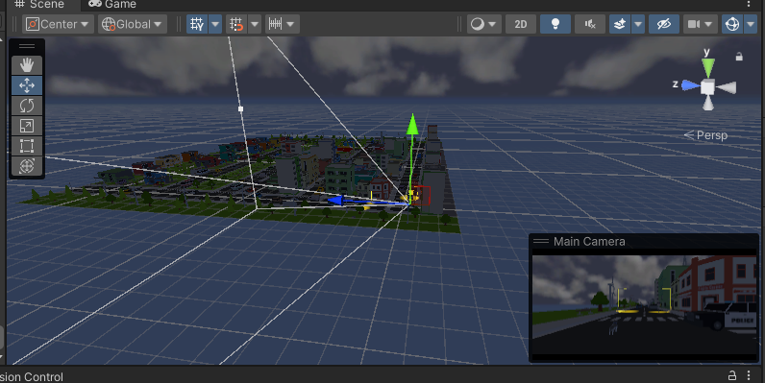

TASK 3:- ADD SKYBOX

Steps:-

Import a sky preset from asset store to make it look more attractive

Insert that material into the dialogue box

Screenshots:-

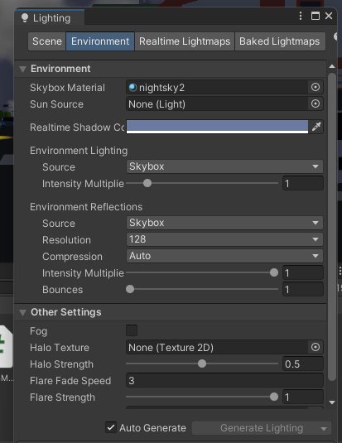

Task 4:- Add Environment Objects:-

Steps:-

Import objects from asset store

Add objects in scene

Now move the object but I couldn’t do it

Screenshots:-

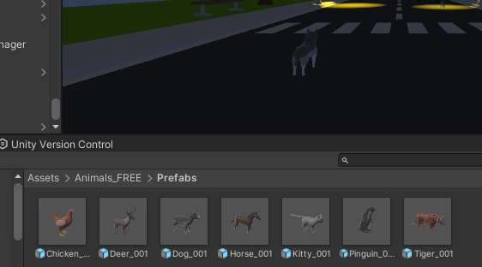

TASK 5:- LIGHTING AND SHADOWS

Steps:-

Add point light below street lamp

Set the range and itensity accordingly

For shadows select hard shadows

Screenshots:-

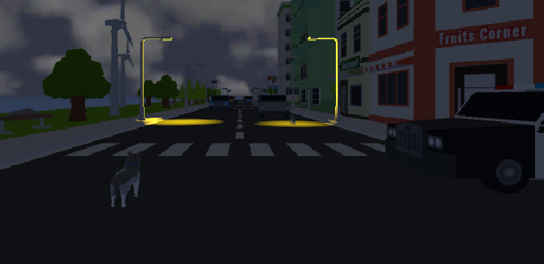

TASK 6:- AUDIO

Steps:-

Download mp3 audio and import it in unity

In audio add component audio source

Drag audio in it

Screenshots:-

